THE OPPOSITES
nasprotja

big - small long - short thin - fat
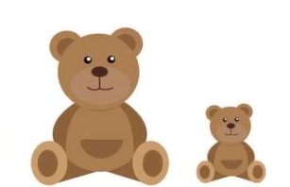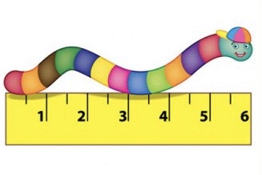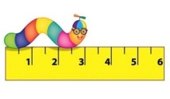

beautiful - ugly young - old tall - short

