PARTS OF THE HOUSE
Match the parts of the house with pictures.
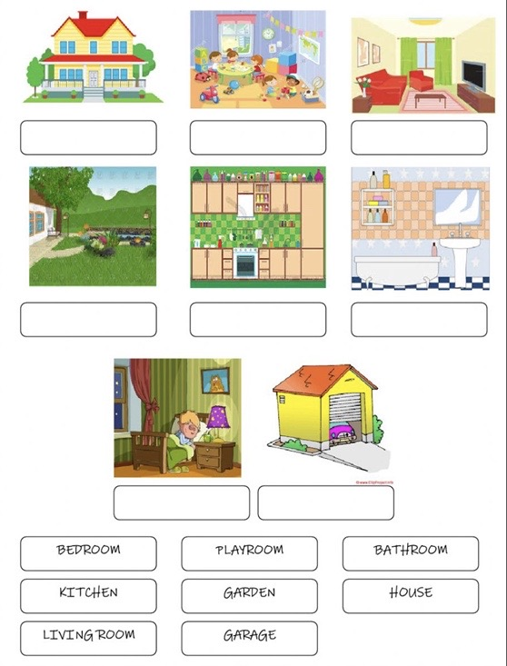
Vir: liveworksheets.com

