I CAN / I CAN'T
ZNAM / NE ZNAM
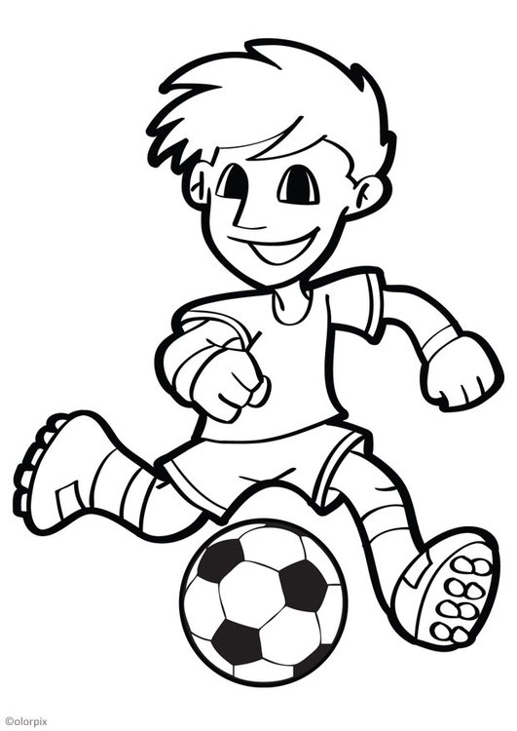

play football - I can play football./I can't play football.
play football - ______________________________________________________
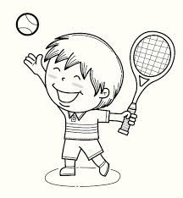
play tennis - ______________________________________________________
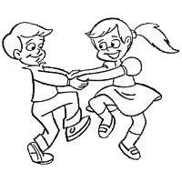

dance - ___________________________________________________________
run - _____________________________________________________________
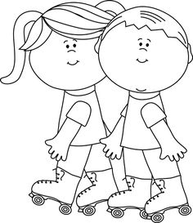
roller skate - ______________________________________________________
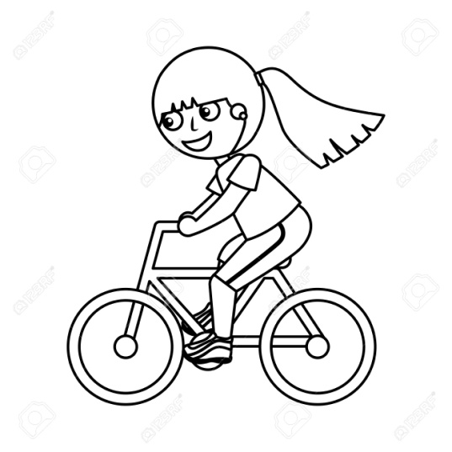
ride a bike - _______________________________________________________

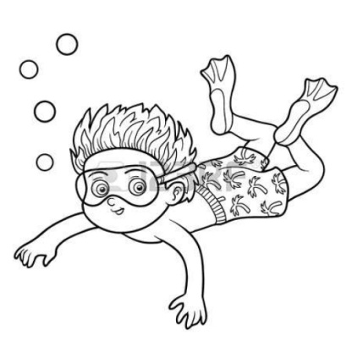
swim - _________________________________________________________

sing - __________________________________________________________

