Goodbye Winter ,

Hello Spring 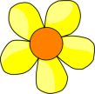

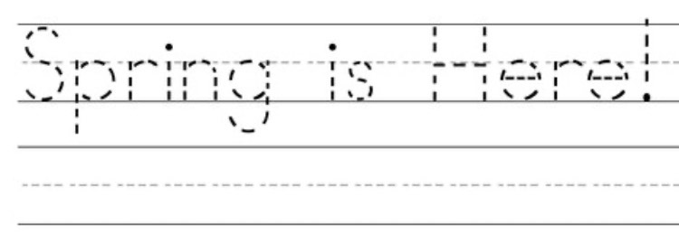

How do you think I know? We just saw a …

Kaj misliš, kako vem? Ravnokar smo opazili …

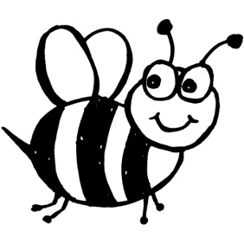 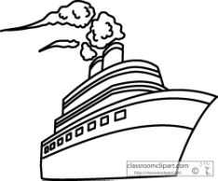 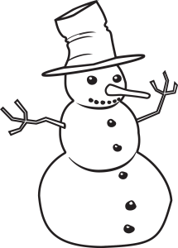 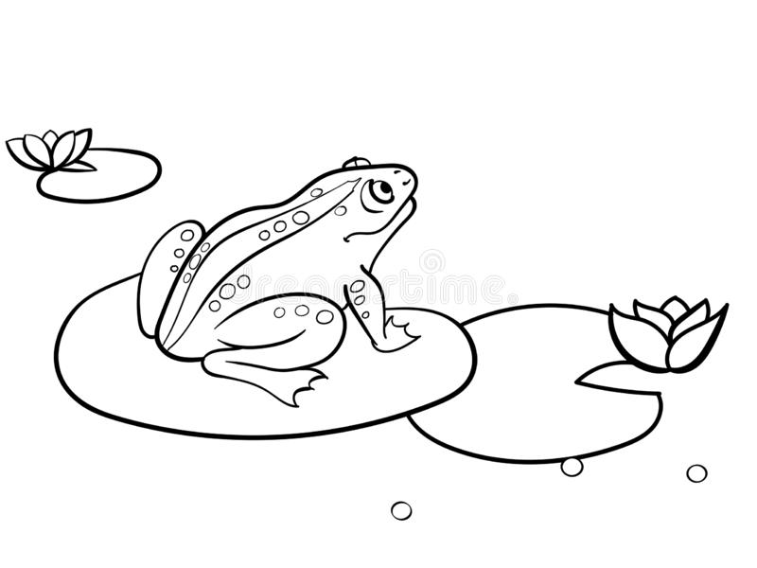

a bee a ship a snowman a frog

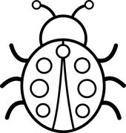 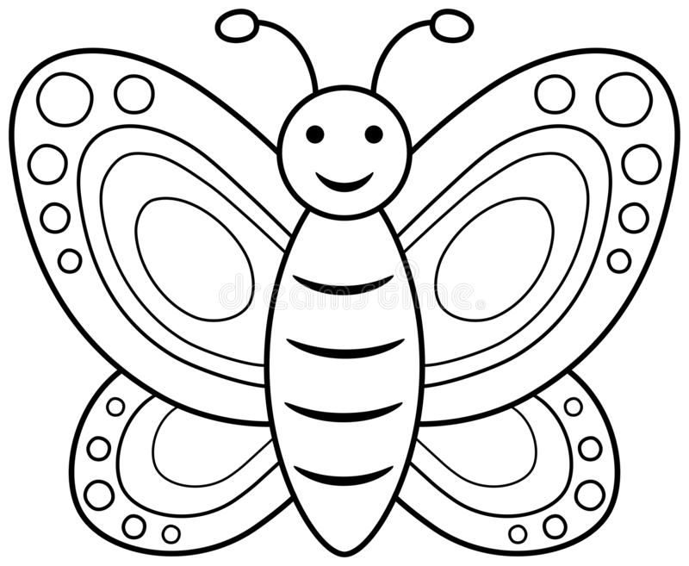  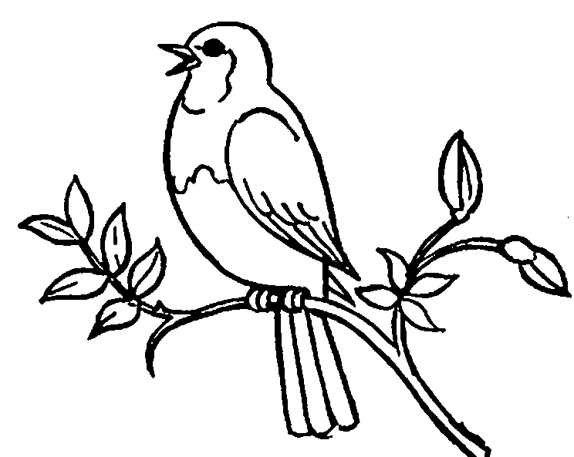

a ladybug a butterfly a monkey a bluebird

We saw a bee,_____________________________________________________ ________________________________________________________________.