Sports
Choose the correct words from the list below and write them under the correct pictures.
Izberi pravilne besede s seznama in jih napiši pod pravilno sliko.

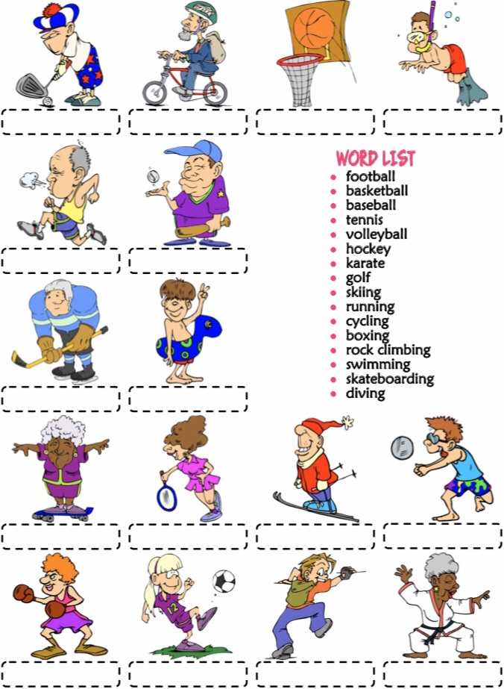
Vir: www.englishwsheets.com

I LIKE ______________________________________________________________________________________________________________________________________________________

I DON'T LIKE
______________________________________________________________________________________________________________________________________________________

