SHAPES
(triangle, circle, diamond, square, heart, star, rectangle, oval)

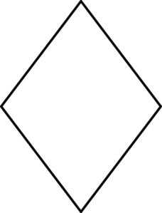
_________________ _________________ _________________ _________________

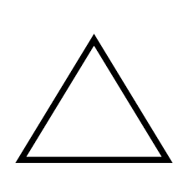
_________________ _________________ _________________ _________________

_ _ _ _ _ _ _ _ _ _ _ _ _ _ _ _ _ _ _ _ _ _ _ _ _ _ _ _ _ _ _ _ _ _ _ _ _ _ _ _ _ _ _ _ _ _ _ _ _ _ _ _ _ _ _ _ _

Draw one object you find at home for each shape into the square!
V vsak prazen kvadrat nariši en predmet, ki ga najdeš doma, za vsako obliko, ki smo jo spoznali.

