SEASONS
WINTER SPRING SUMMER AUTUMN
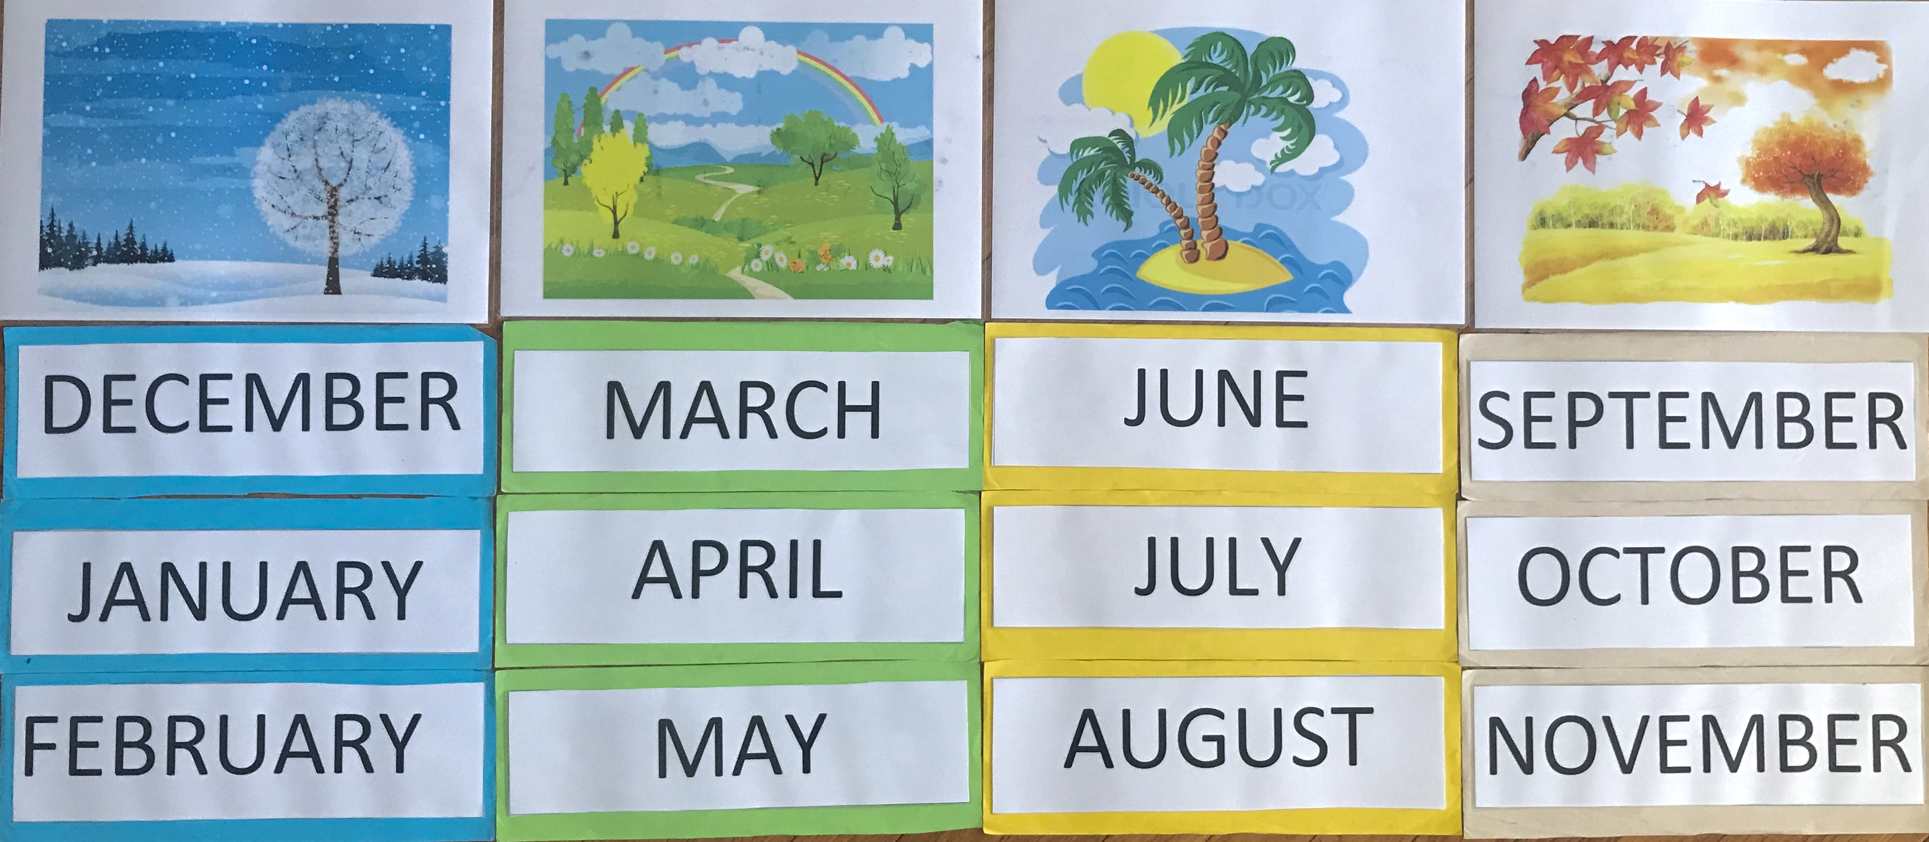

Book p. 83/1.b
Seasons | Start | Weather | Plants | Animals
Spring
Summer
Autumn
Winter

Book p. 83/1.c
1. It's spring. It's windy.
- I'm wearing an anorak.
- I'm flying a kite.
2. It's summer. It's hot.
- I'm …

