**Preveri svoje znanje**

1. Read the text. Then read the statements. Are they true or false? Mark: or .

Preberi besedilo. Nato preberi trditve. Ali držijo ali ne držijo? Označi: ali .

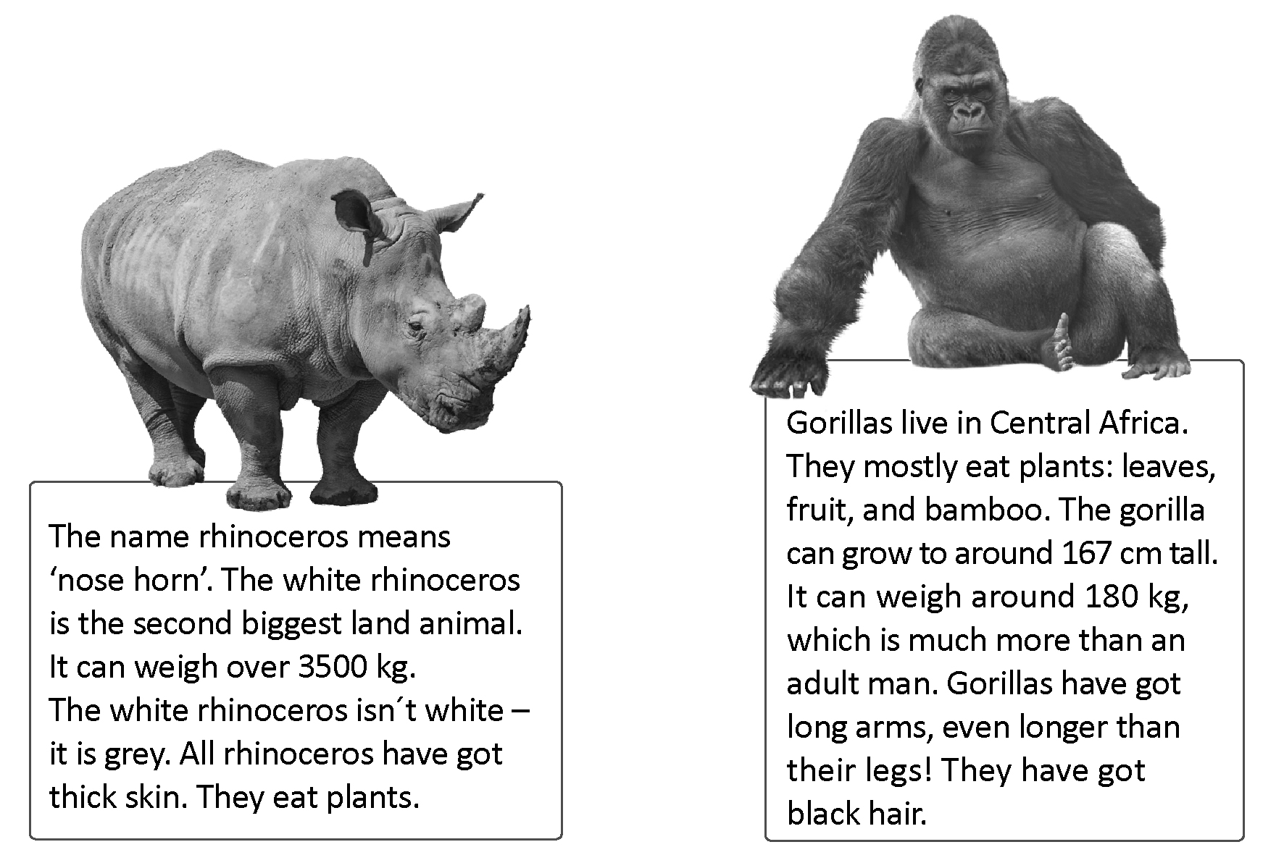

 **True False**

The white rhinoceros is the biggest land animal.

The white rhinoceros is white.

Rhinoceros eat plants.

Gorillas don´t eat fruit.

The gorilla can weigh more than a man.

Gorillas have got black hair.

2. Compare the animals on the cards.

Primerjaj živali na karticah. Napiši povedi.

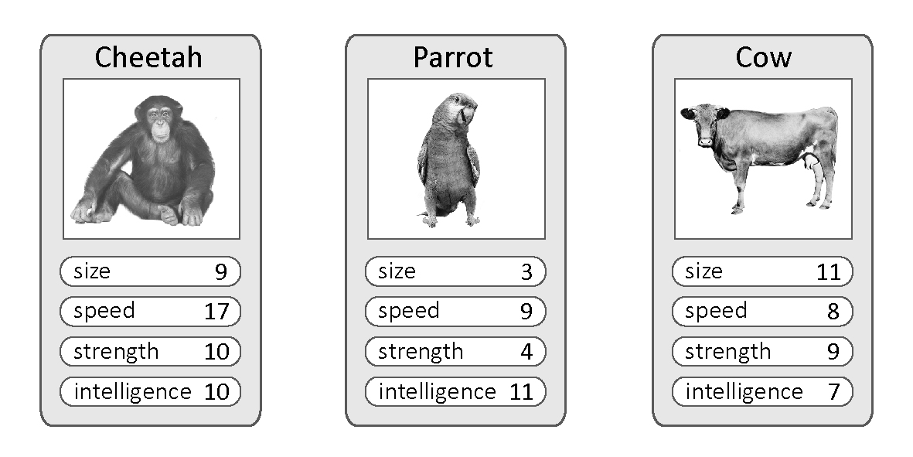

A cheetah is smaller than a cow.

(cheetah, cow: small)

1. (parrot, cow: strong)

2. (cheetah, cow: fast)

3. (parrot, cow: intelligent)

4. (cheetah, parrot: big)

5. (cheetah, parrot: slow)

1. What are the children doing? Look at the pictures and write five sentences.

Kaj delajo otroci? Oglej si risbe in napiši pet povedi.

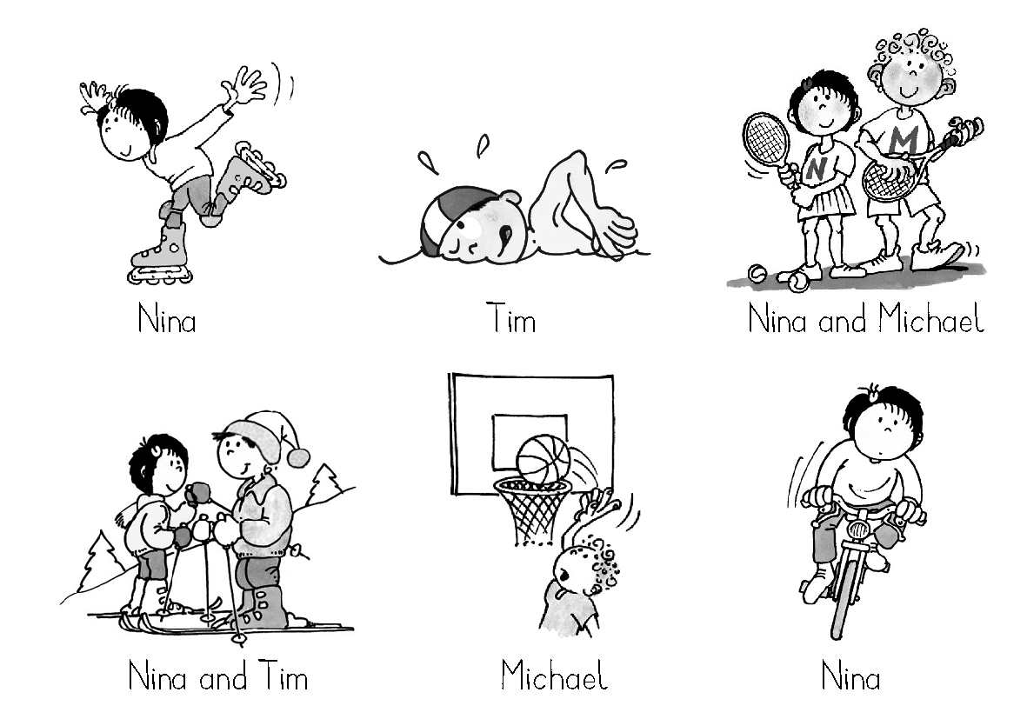

Nina is in-line skating.

4. Read the text under the first picture and colour the picture. Then colour the second picture and write sentences about it.

Preberi besedilo pod prvo sliko in sliko pobarvaj. Nato pobarvaj drugo sliko in napiši

povedi o njej.

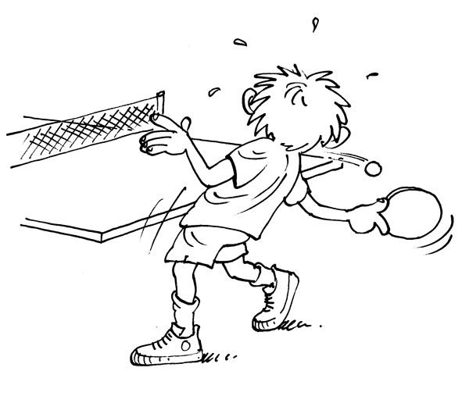

The table tennis player is wearing a green T-shirt, blue shorts, yellow socks and black sport shoes. He's hitting the ball with a red tennis table racket.

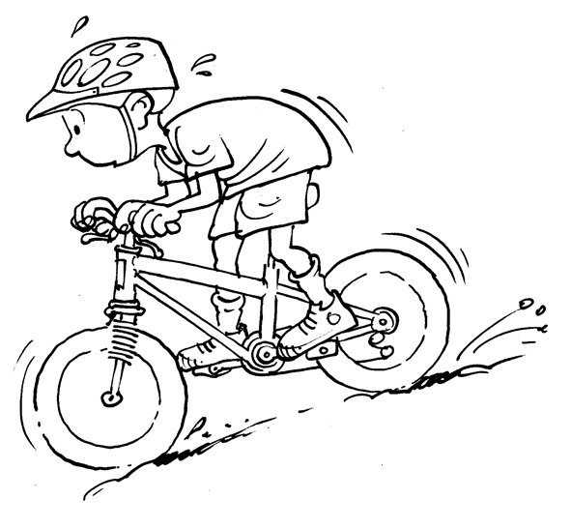

5. Answer the questions.

Odgovori na vprašanja.

A racket and a shuttlecock.

What do you need for playing badminton?

What do you need for playing football?

What do you need for playing basketball?

What do you need for horse riding?

What do you need for snorkelling?