PROFESSIONS
POKLICI
1. Listen and say. https://www.youtube.com/watch?v=R69YKFmlcnA
2. Read and write.

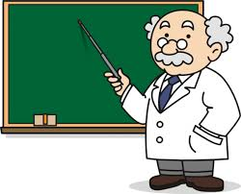 John works in a school. _He_ is a ___teacher___.
Mia works in a studio. ______is an _______________________.
Marc works in an animal hospital. ______is a _______________.
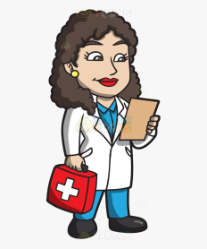 Julia works in a hospital. ______ is a _______________________.
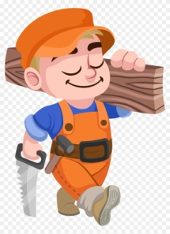 Mark works in a carpenter's shop. ______ is a _______________.
John works in a restaurant. ______ is a ____________________.
Maria works in a factory. ______ is an ________________________.
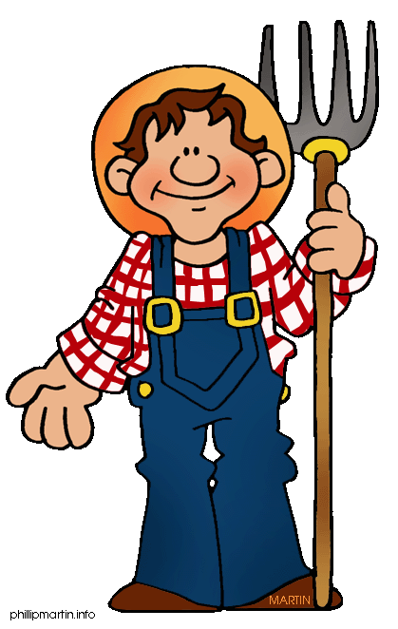 George works in a farm. ______ is a _________________________.
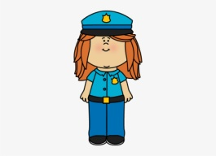Rebecca works at a police station. ______ is a ______________.
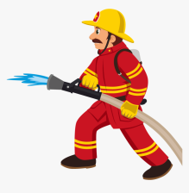 Mark works at a fire station. ______ is a ____________________.
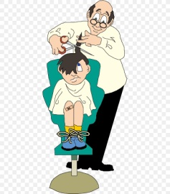 Michael works in a salon. ______ is a ______________________.
Bob sings. ______ is a __________________________________.
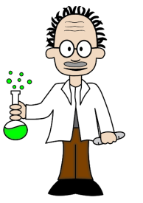Alex works in a science lab. ______ is a ____________________.
Luka flies airplanes. ______ is a ____________________.

What would you like to be when you grow up? Kaj bi bil/a rad/a po poklicu?
I would like to be a _______________________________.

