MY BODY
Match the body parts with the picture.
Prepiši dele telesa v pravilen kvadrat ob sliki.

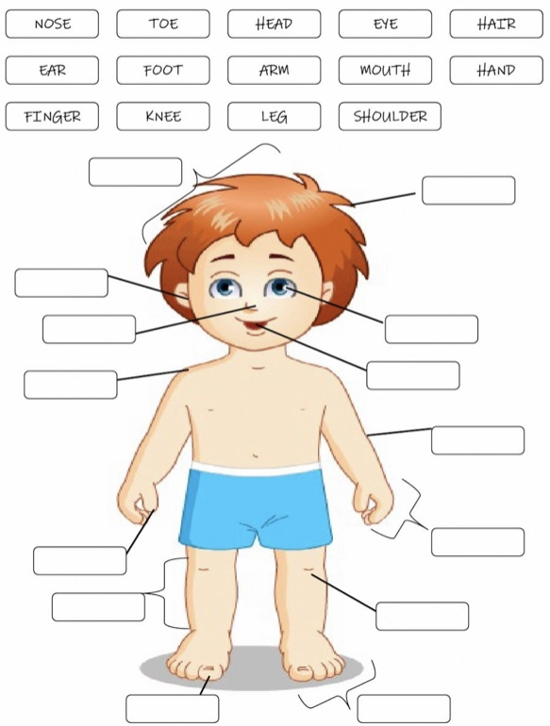
Vir: https://www.liveworksheets.com/worksheets/en/English_as_a_Second_Language_(ESL)/Body_Parts/My_Body_lj17566mb

