How many? Koliko …?
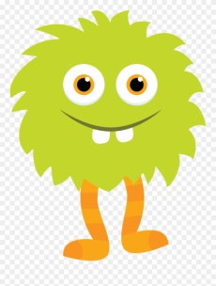

How many eyes? _____Two eyes.________
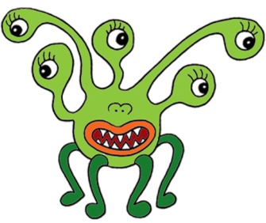
How many eyes? ________________________.

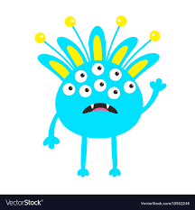

How many ears ? __________________________.

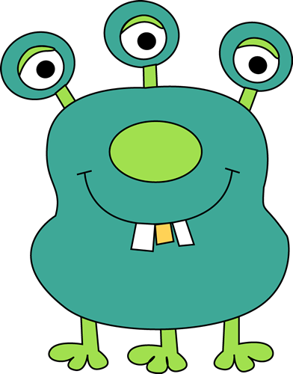
How many legs? __________________________.

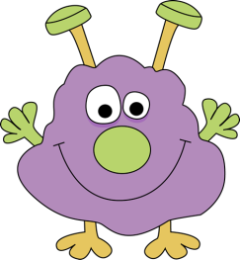

How many noses? _________________________.

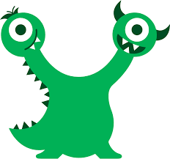
How many heads? ___________________________.

Draw a monster with:
- three yellow heads,
- grey hair,
- six blue eyes,
- nine purple noses,
- two green ears,
- one orange body,
- three brown legs.

